# **Name: Abdurrahman Qureshi**

# **Roll No: 210451**

Practical No: 4

**1) Write a PHP script to Create and display Index array, Associative array and Multidimensional array**

**CODE:**

<?php  
 echo "Indexed array:" . "<br>";  
 $qarq90_indexed = ["spectre","serpah","sparrow","battery","reaper","firebreak"];  
 print_r($qarq90_indexed);  
 echo "<br>";  
 echo "<br>";  
  
 echo "Associative array:" . "<br>";  
 $qarq90_associative = [  
 "agent1" => "spectre",  
 "agent2" => "seraph",  
 "agent3" => "sparrow",  
 "agent4" => "battery",  
 "agent5" => "reaper",  
 "agent6" => "firebreak"  
 ];  
 print_r($qarq90_associative);  
 echo "<br>";  
 echo "<br>";  
  
 echo "Multidimensional array:" . "<br>";  
 $qarq90_multidimensional = [  
 ["agent" => "spectre"],  
 ["agent" => "seraph"],  
 ["agent" => "sparrow"],  
 ["agent" => "battery"],  
 ["agent" => "reaper"],  
 ["agent" => "firebreak"]  
 ];  
 print_r($qarq90_multidimensional);  
 echo "<br>";  
?>

**OUTPUT:**

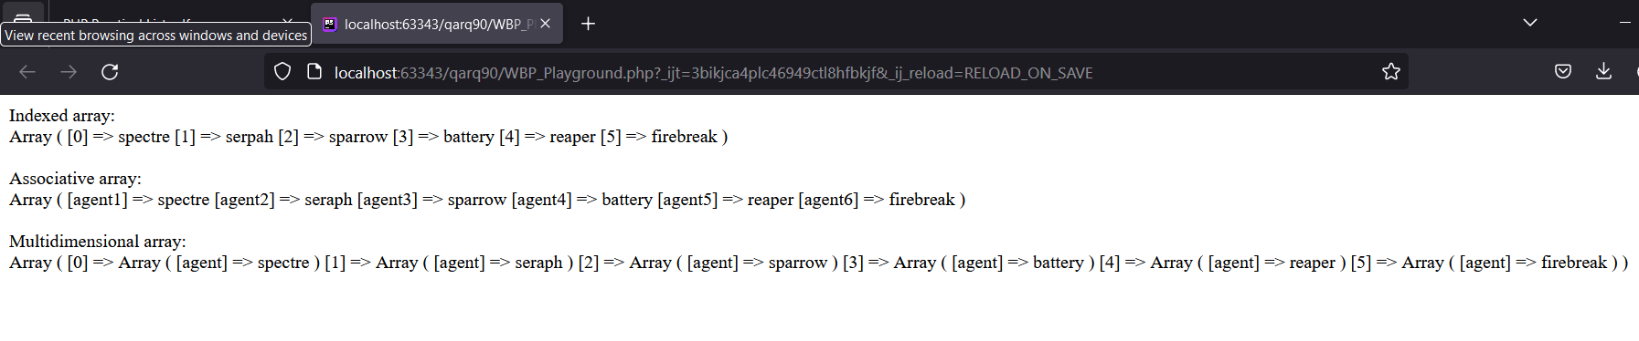

**2) Write a PHP script to sort an array in ascending order**

**CODE:**

<?php  
 echo "Indexed array:" . "<br>";  
 $qarq90_indexed = [56,15,15,1,32,1,5];  
  
 echo "Original Array: " . "<br>";  
 print_r($qarq90_indexed);  
  
 $length = count($qarq90_indexed);  
  
 for ($i = 0; $i < $length - 1; $i++) {  
 for ($j = 0; $j < $length - $i - 1; $j++) {  
 if ($qarq90_indexed[$j] > $qarq90_indexed[$j + 1]) {  
 $temp = $qarq90_indexed[$j];  
 $qarq90_indexed[$j] = $qarq90_indexed[$j + 1];  
 $qarq90_indexed[$j + 1] = $temp;  
 }  
 }  
 }  
  
  
echo "Sorted Array: " . "<br>";  
 print_r($qarq90_indexed);  
  
?>

**OUTPUT:**

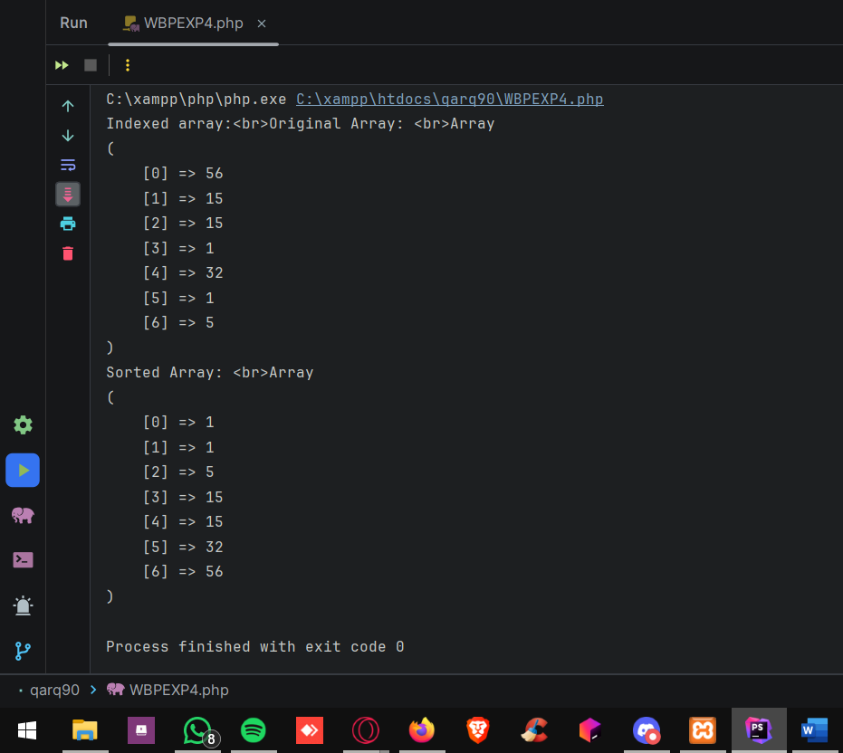

**3) Write a PHP script to perform searching in an array.**

**CODE:**

<?php  
 $qarq90_indexed = [56,15,15,1,32,1,5];  
  
 $length = count($qarq90_indexed);  
  
  
 for ($i = 0; $i < $length - 1; $i++) {  
 echo $qarq90_indexed[$i] . " - ";  
 }  
  
 $search = 32;  
  
 for ($i = 0; $i < $length - 1; $i++) {  
 if ($qarq90_indexed[$i] == $search) {  
 echo "Found 32 at " . $i;  
 }  
 }  
?>

**OUTPUT:**

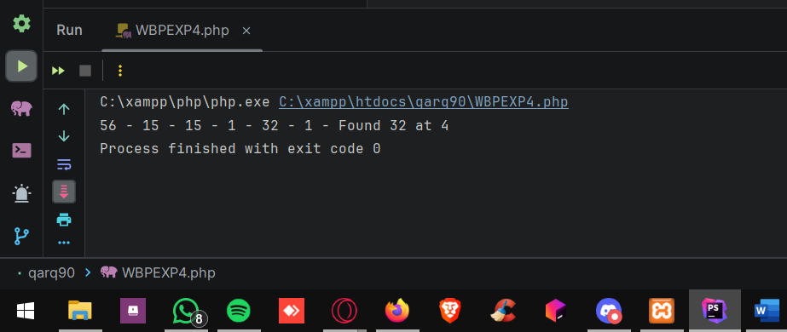

**4) Write a PHP script to find minimum and maximum value in an array.**

**CODE:**

<?php  
 $qarq90_indexed = [56,15,15,1,32,1,5];  
  
 $length = count($qarq90_indexed);  
  
  
 for ($i = 0; $i < $length - 1; $i++) {  
 echo $qarq90_indexed[$i] . " - ";  
 }  
  
 $max = $qarq90_indexed[0];  
 $min = $qarq90_indexed[0];  
  
 for ($i = 0; $i < $length - 1; $i++) {  
 if ($qarq90_indexed[$i] > $max){  
 $max = $qarq90_indexed[$i];  
 }  
 if ($qarq90_indexed[$i] < $min){  
 $min = $qarq90_indexed[$i];  
 }  
 }  
  
 echo "\n" . "Largest: " . $max . "\n";  
 echo "Smallest: " . $min;  
?>

**OUTPUT:**

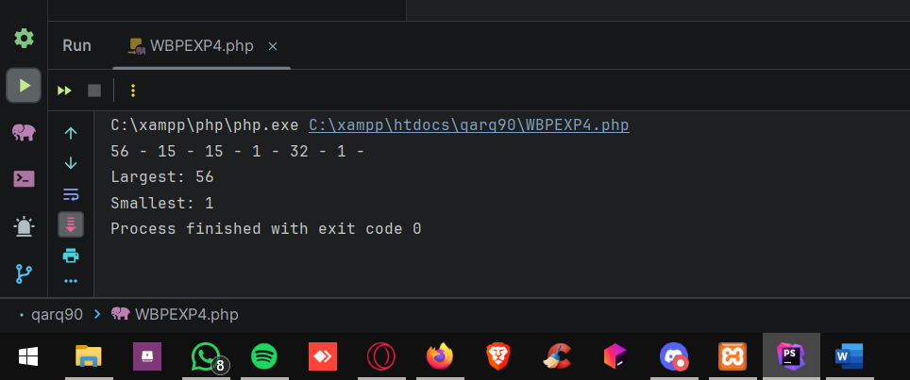

**5) Write a PHP script to perform searching in a two dimensional array.**

**CODE:**

<?php  
 $qarq90_indexed = [[56,15],[1,32],[1,5]];  
  
 $length = count($qarq90_indexed);  
  
 for ($i = 0; $i < $length - 1; $i++) {  
 for ($j = 0; $j < $length - 1 ; $j++){  
 echo $qarq90_indexed[$i][$j] . " - ";  
  
 }  
 }  
  
 $search = 32;  
  
 for ($i = 0; $i < $length - 1; $i++) {  
 for ($j = 0; $j < $length - 1 ; $j++){  
 if ($qarq90_indexed[$i][$j] == $search) {  
 echo "Found 32 at " . $i . $j ;  
 }  
 }  
 }  
?>

**OUTPUT:**

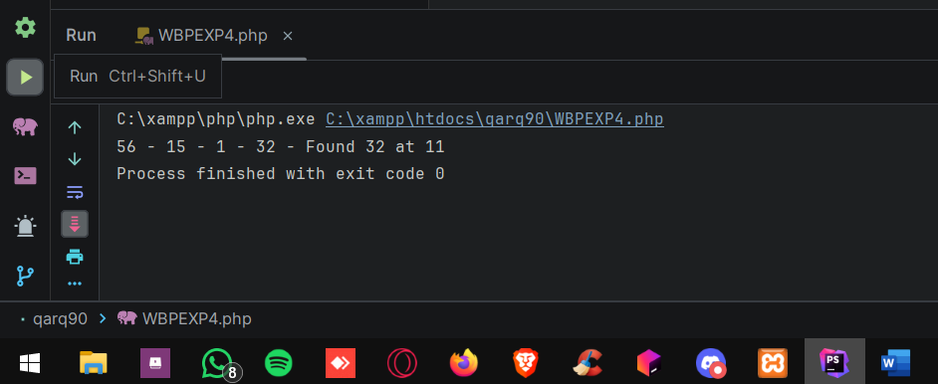

**6) Write a PHP script to find minimum and maximum value in a two**

**dimensional array.**

**CODE:**

<?php  
$qarq90_indexed = [[56,15],[1,32],[21,500]];  
  
$length = count($qarq90_indexed);  
  
for ($i = 0; $i < $length ; $i++) {  
 for ($j = 0; $j < $length ; $j++){  
 echo $qarq90_indexed[$i][$j] . " - ";  
  
 }  
}  
  
$max = $qarq90_indexed[0][0];  
$min = $qarq90_indexed[0][0];  
  
for ($i = 0; $i < $length; $i++) {  
 for ($j = 0; $j < count($qarq90_indexed[$i]); $j++) {  
 if ($qarq90_indexed[$i][$j] > $max) {  
 $max = $qarq90_indexed[$i][$j];  
 }  
 if ($qarq90_indexed[$i][$j] < $min) {  
 $min = $qarq90_indexed[$i][$j];  
 }  
 }  
}  
  
echo "\n" . "Largest: " . $max . "\n";  
echo "Smallest: " . $min;  
  
?>

**OUTPUT:**

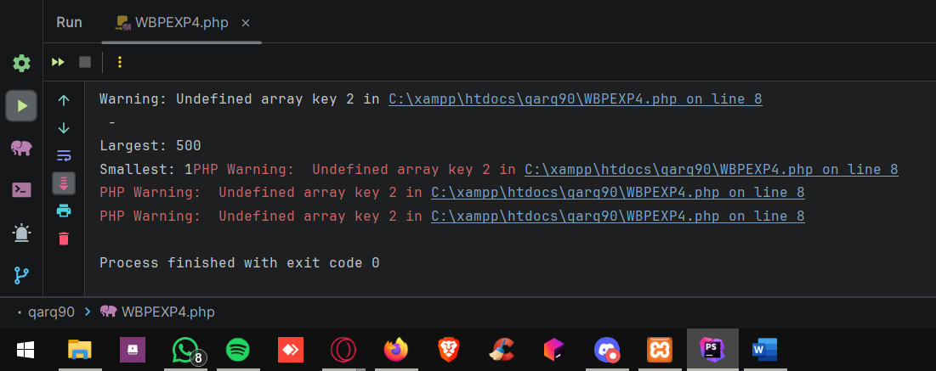

**7) Write a PHP script to demonstrate the use of explode() function**

**CODE:**

<?php  
$fruitsString = "apple0banana0orange";  
  
$fruitsArray = explode("0", $fruitsString);  
  
print_r($fruitsArray);  
?>

**OUTPUT:**

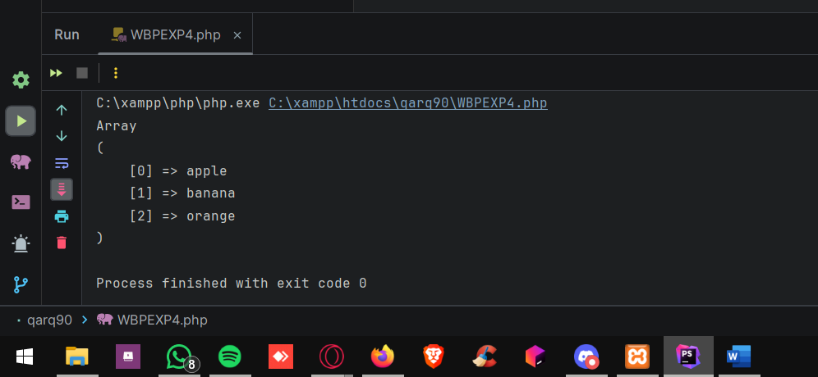

**8) Write a PHP script to demonstrate the use of implode() function**

**CODE:**

<?php  
$colors = array("red", "green", "blue", "yellow");  
  
$commaSeparated = implode(", ", $colors);  
  
echo $commaSeparated;  
?>

**OUTPUT:**

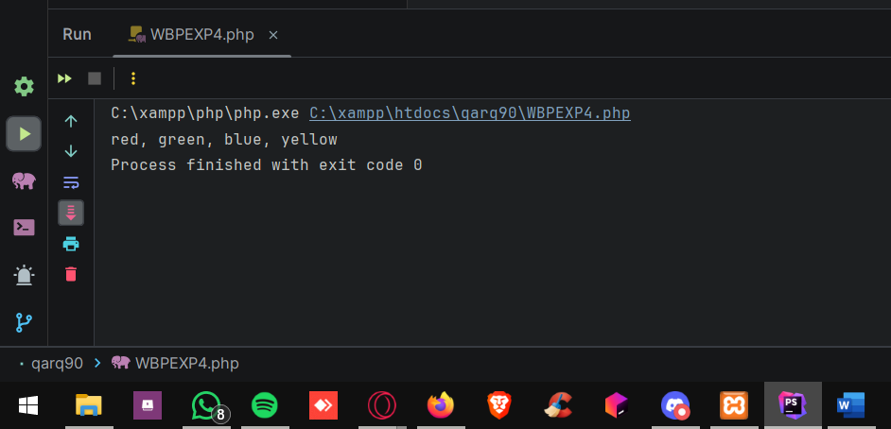

**9) Write a PHP script to demonstrate the use of array_flip() function**

**CODE:**

<?php  
$originalArray = array("one" => 1, "two" => 2, "three" => 3);  
  
$flippedArray = array_flip($originalArray);  
  
print_r($flippedArray);  
?>

**OUTPUT:**

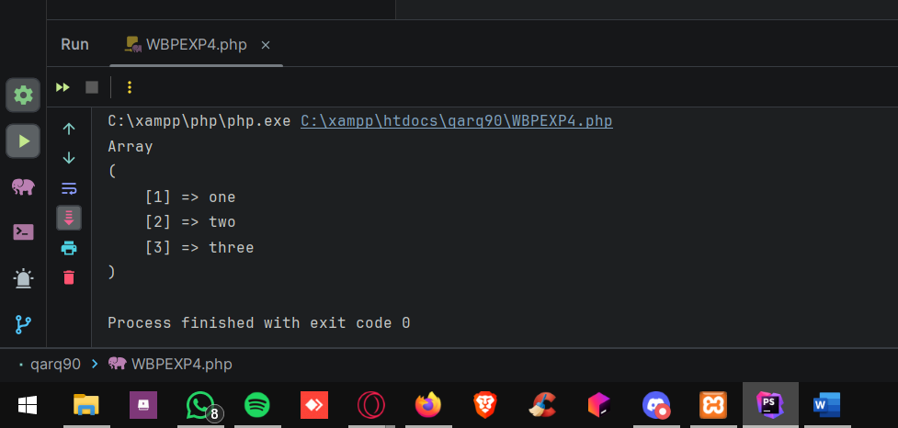

**10) Write a PHP script to demonstrate the use of array_walk() function**

**CODE:**

<?php  
 $arr_og = [514,56,15,15,1,5];   
 function sqr(&$n) {  
 return $n * $n; }  
 array_walk( $arr_og,"sqr");  
 print_r($arr_og)?>

**OUTPUT:**

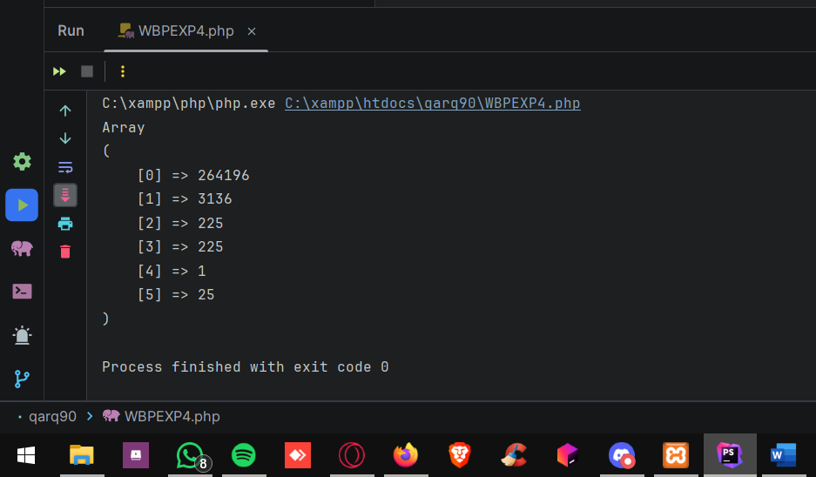

**11) Write a PHP script to demonstrate the use of array_map() function**

**CODE:**

<?php  
 $arr_og = [514,56,15,15,1,5];   
 function sqr($n) {  
 return $n * $n; }  
  
$arr_og2 = array_map("sqr", $arr_og);  
  
 print_r($arr_og2)?>

**OUTPUT:**

